# Introduction

The objective of our application is to help university and its departments to improve the quality of education by gathering information such as their five years’ job performance from their graduated students. Our application can implement the following functions:

1. University can access to the rank list of all graduates. Based on graduate rank and other factors like the quantity of the laboratory, the proportion of international students and teachers, graduate employment rate and so on, the university can get their own university rank score, department rank score, course rank score and compare with different academic units or other universities.
2. Each department can access to the rank list of its own graduates. Based on department graduate rank and other factors like employment rate, each department can get their own rank score and compare with other departments.
3. Each graduate has a transcript. Based on the rank list and the course selection of each student. Department can get the course rank which can track the connection of courses and their relevance to graduates growth, and evaluate how an educational system in terms of faculty and courses contribute to the growth of their graduates over a 5-year period.

In the next section, we will explain the principle of each function in details.

# Application Details

## Graduate Rank

This rank list is totally based on the job performance of the graduates after they graduated from their university. The reason why we do not consider the graduates’ situations in the university is that to make sure this rank list can truly reflect the situation of students after their graduation.

When these graduates made feedback to university, we can get their initial income and current income, initial job position and current job position, and the employer evaluation as well，the system can use the method .getImprovement() to calculate the improvement of each graduate’s job performance through the difference of their initial income/job position and current income/job position. The specific implementation method will be mainly calculating the salary increase and rising position to define each graduate’s job performance improvement and additionally consider the employer evaluation.

In this rank system, we assume that all the companies and corporations have the same job position system, which can make the job position evaluation quantifiable. After doing this, each graduate can get a rank and the university can get a rank list from top 1 graduate.

## University Rank

Each university can get its own university score through the university rank system. The rank system demands the specific and detailed information about this university. Our university rank system is a comprehensive consideration system.

The rank formula in our university rank system will be :

University Rank = 30%Academic + 20% campus environment + 50% graduate Rank.

The specific considerations of academic are the total number of students at university, total number of professors, so that we can use getPSRatio() to get the professor-student ratio, the number of departments, number of paper cited. The specific considerations of campus environment are the number of laboratories, the number of libraries, area covered. The graduate rank is what we have mentioned before. Eventually, we can use the method .getUniversityRank() to get the university rank.

## Department Rank

This is the function that retrieves the rank of a department of a university. There would be a dashboard that enables college and university administrators to compare the performance of their academic units

To get the rank of a department, Administrator uses Class University, who uses its own getDepartmentRank() method. Then Class Department would get all the Employees in its own department(getList()) from Class DepartmentEmployeeList, which would return a list that the Class Department requires. Then, Class DepartmentEmployeeList would iterate every member in the returned list and get their scores, which represents the improvement of an employee or graduate, and calculate average of the sum, then return to Class Department.

Class University would get a score of every department and put them in its list that have every departments’ score. Finally, Class University would sort the departments in the list by scores it got just now and return a rank that the Administrator wants.

## Course Rank

Course Rank is a rank that evaluate the quality of the courses which are offered by each department in universities, and it is mostly based on Employee rank. All the courses from one specific department will be sorted through the performance of all the graduates who graduated from school over 5 years, and university graduates provided feedbacks of their salary and promotion times to their school.

The method we achieve the course rank is to classify the department employee rank into several layers, such as top 10%, 11~20%, 21~30% employees and so on, and retrieve the courses each layered employee had attended, so that all courses can be sorted through the number of times appeared in different layers. For example, course INFO 5100 appear 100 times in top 10% layer, 50 times in 20%~30% layer and 10 times in 80%~90% layer, so INFO 5100 is a high-quality course because [the](javascript:;) [majority](javascript:;) [of](javascript:;) top-ranked graduates have taken this course. It also could be sorted by different department.

For technical part, from the ER diagram, Course Rank can use method .getCourseRank() to be calculated, and .getCourseRank can be calculated from CourseCatalog() in  department class, and the rest can be done in the same manner.

# Conclusion

The application we designed is mainly display a performance measurement solution to enable universities to measure the quality of the education they deliver to their students.

Method .getImprovement() allows an educational system to check education quality in terms of faculty and courses contribute to the growth of their graduates over a 5-year period. Method .getEmployeeRank() is the way to track the jobs and promotions graduates get over time and assign rankings accordingly. Method .getCourseRank() tracks the connection of courses and their relevance to graduates growth. Method .getDepartmentRank() enables college and university administrators to compare the performance of their academic units by a dashboard. Last but not the least, method .getUnivRank() forms a ranking system of educational institutions defined by ourselves.

All the ranking data can be updated after re-calculating, and new ranking data can be created to the system. From the above, our system can offer graduates rank, department rank, course rank and university rank to university administrators, and allows different academic units and schools to compare with each other so that the quality of education can be improved time after time, and the currently enrolled students can benefit more from their university.

# Object model

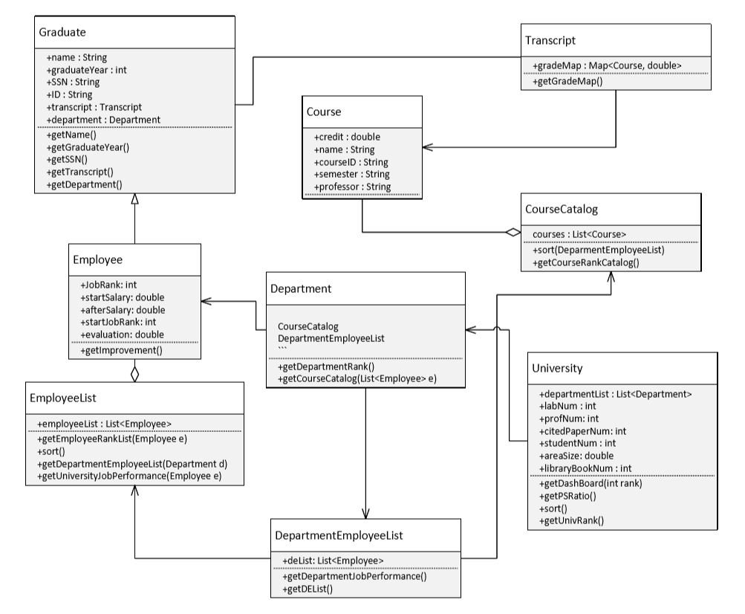

# Sequence diagrams

